Week 8 Lab session exercises

Task 1. Visualise more classes (probability maps)
Select a category or class, and extend the code in cell 7 to correctly overlay the segmentation mask of the chosen category on every image.

Answer
By selecting dog, car and person we can find cars and person in Mexico-City.jpg and dog and person in the Street.jpg image.

****
# **Task 1. Visualise more classes (probability maps)**

sem_class_to_idx = {cls: idx for (idx, cls) in enumerate(weights.meta["categories"])}

TestImg_ProbMasks = [
normalized_masks[img_idx, sem_class_to_idx[cls]]
for img_idx in range(len(TestImg_list))
for cls in ('dog', 'car','person')
]

show(TestImg_ProbMasks)
****
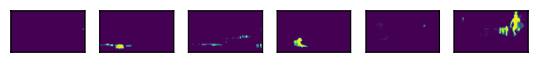

Task 2. Overlay segmentation masks.
Select a category or class, and extend the code in cell 7 to correctly overlay the segmentation mask of the chosen category on every image.

Answer
***
# **Task 2. Overlay segmentation masks.**
boolean_img_masks = (normalized_masks.argmax(class_dim) == sem_class_to_idx['person'])

img_with_masks = [
draw_segmentation_masks(img, masks=mask, alpha=0.7, colors=[(0, 200, 0)])
for img, mask in zip(TestImg_list, boolean_img_masks)
]
show(img_with_masks)
***

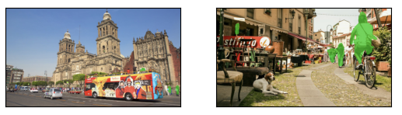

Task 3 3. All masks All Images**
Visualise masks for all detected classes across the batch of images, but this time remove the background mask on each image (removing the background mask is as simple as the background class is the class with index 0).

***
class_dim = 1
all_classes_masks = normalized_masks.argmax(class_dim) == torch.arange(num_classes)[:, None, None, None]
print(f"shape = {all_classes_masks.shape}, dtype = {all_classes_masks.dtype}")
# The first dimension now represents the classes, so we need to swap it
all_classes_masks = all_classes_masks[1:,:,:,:]
all_classes_masks = all_classes_masks.swapaxes(0, 1)
